**Website URL**

**Live** : <https://www.halocheck.com.my/>

**How to manage Header for desktop**

**To manage the content of the Header for desktop,**

**follow the steps below:**

1. Log in to your dashboard.

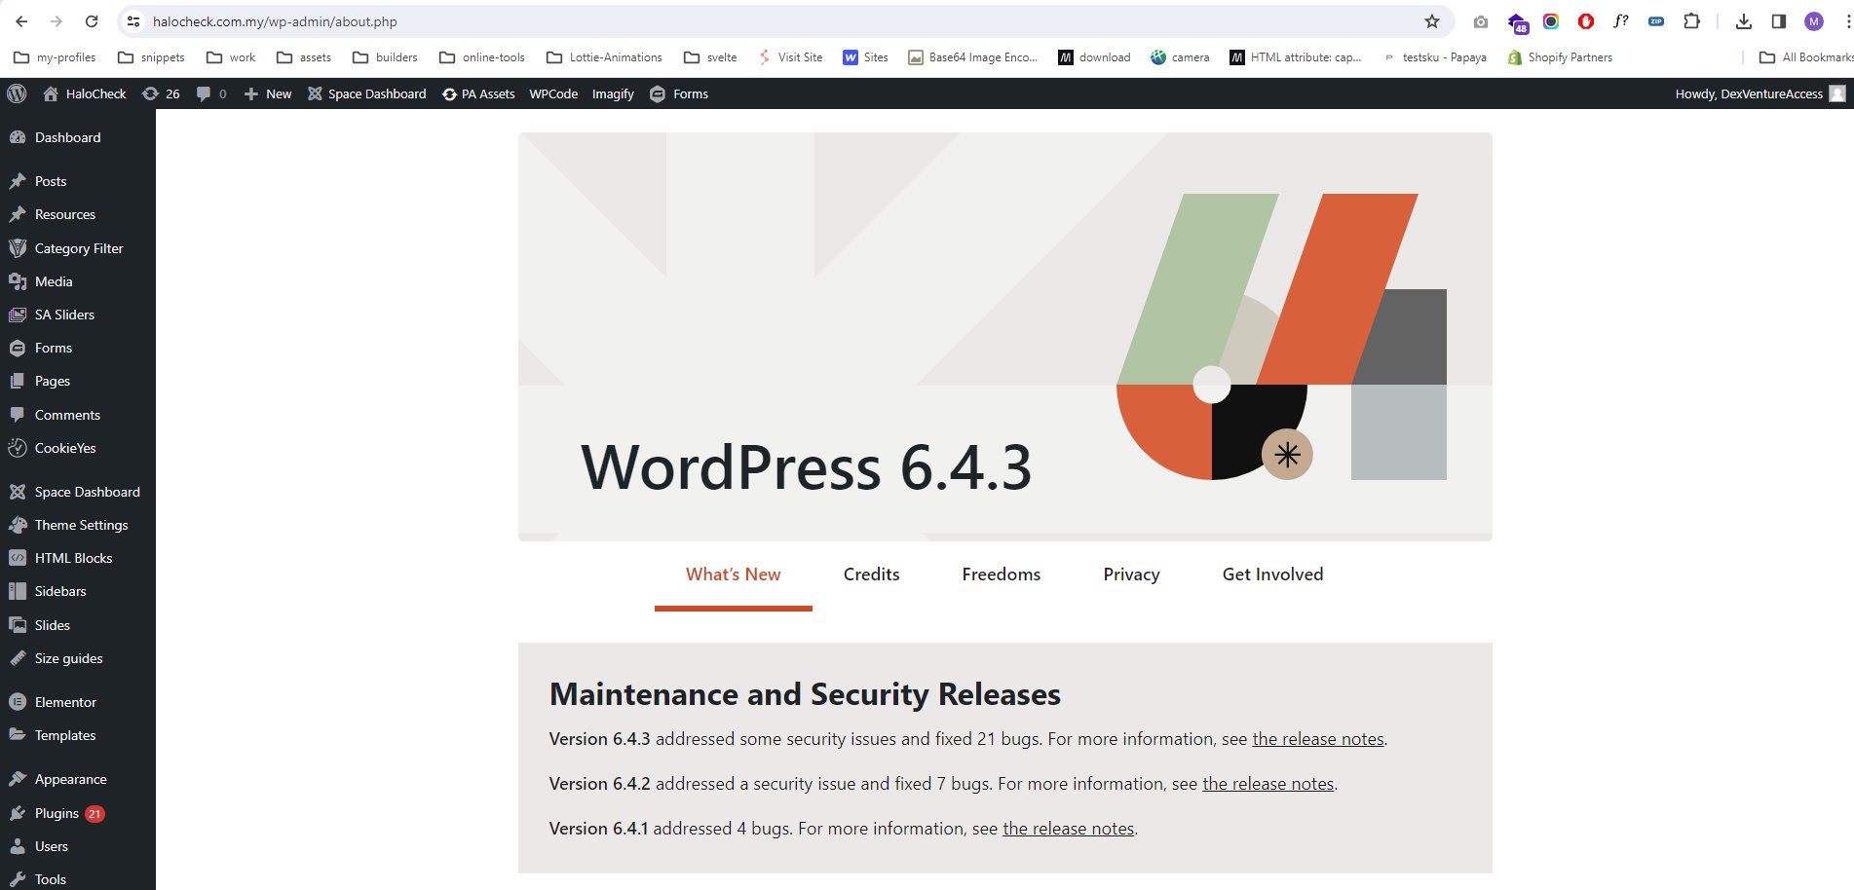

2. Navigate to the "**Theme Settings > General**" option.

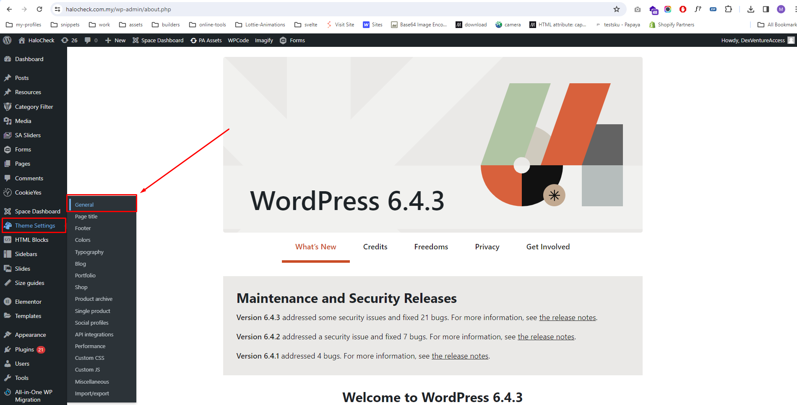

3. Select the "**Header Builder**" option.

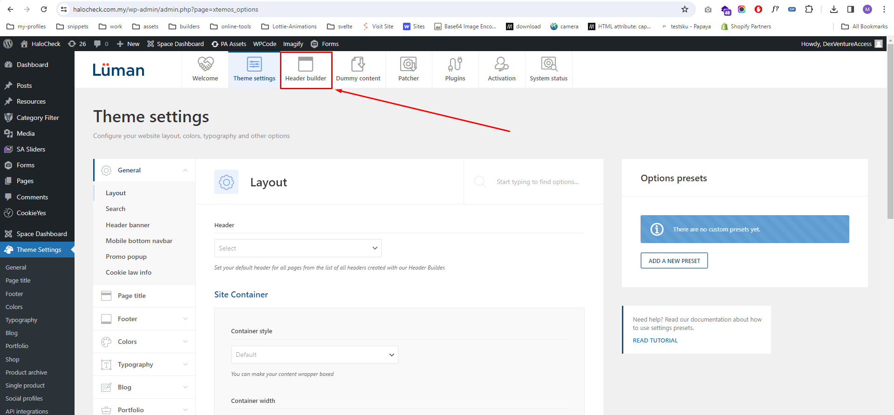

4. Click on the "**Edit**" button to modify the header.

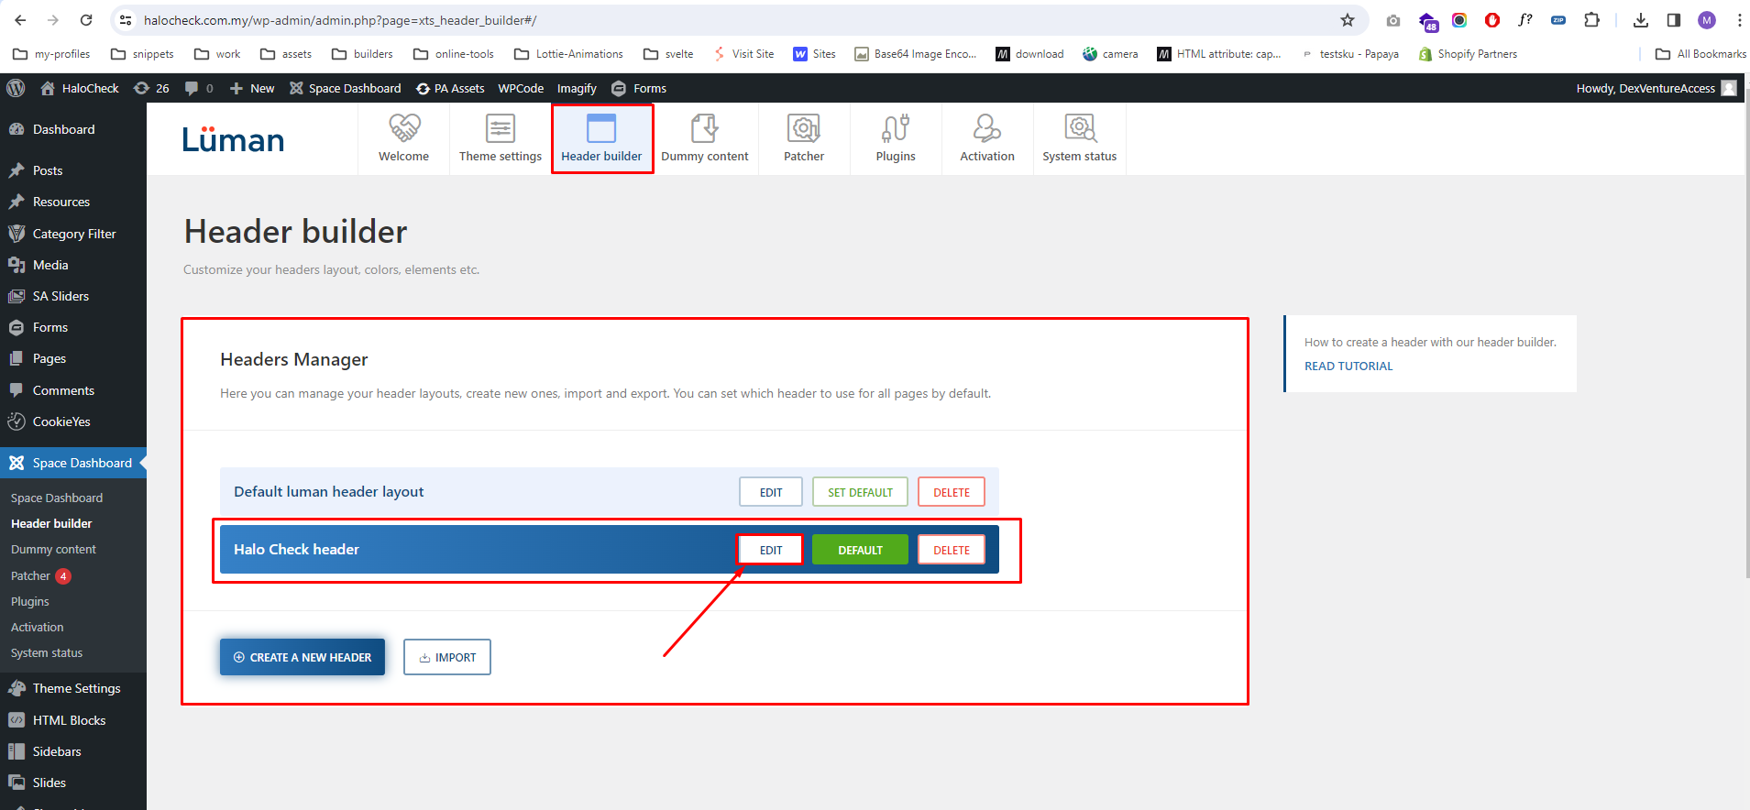

5. Locate the edit icon to change the **URLs** for buttons.

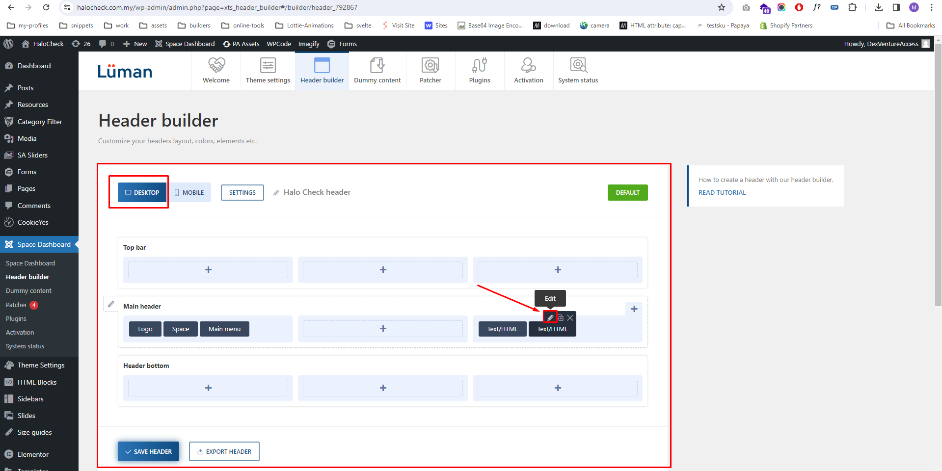

6. Click on the edit URL, save the changes, and then verify.

